SLT

COMMUNICATION
AND ORACY
Policy Document 2023
Hayfield School

Contents
1 Curriculum Intent Hayfield 3
Philosophy 3
Values 3
2 Curriculum Intent: EYFS framework and National Curriculum 4
EYFS Framework 2021 4
National Curriculum 4
Definition 4
Aims 4
3. Curriculum Implementation of communication and oracy: 4
When is communication and oracy taught at Hayfield? 4
How is communication and oracy taught at Hayfield? 4
4 Impact of communication and oracy: 5
Summative Assessment 5
Formative Assessment 5
Appendix 1: Communication Pathway 5
Appendix 2: AET Framework 5
Appendix 3: 5

1 Curriculum Intent Hayfield

Philosophy
1.1
At Hayfield School, we work towards ‘Learning to Live and Love Life Together’. Our highest expectations inspire children to embrace learning and life as an adventure. As well as our Children reaching their highest academic potential, at Hayfield we practice a child-centred holistic approach and by Y6 our agreed cumulative goals for our children is that children at Hayfield can reach or be on a positive path to acquiring the following life skills:
- Are Confident and Independent
- Have strong Self Help Skills
- Take Responsibility for their own learning and recognise links with the outside world
- Respect themselves and others; and take Responsibility for their own behaviour and demonstrate Tolerance
- Develop Thinking skills in order to make Positive Choices

1.2
As well as the statutory Objectives laid out in the National Curriculum for Communication and Language/Spoken language, this subject is used as a means of children achieving the following objectives:
- Inspire them to be responsible citizens
- Reflect and evaluate their learning in order to move forward
- Able to seek solutions out of problems.
- Able to share the responsibility to earn and show respect.
- Recognise rewards are on the journey, not just the destination.
- Believe in themselves

Values
1.3
The Communication and Oracy curriculum at Hayfield School is underpinned by the philosophy expounded through our values and the Goals of Education stated in Article 29 of the UN Convention of the Rights of the child. Therefore, as well as aspiring to the statutory attainment outcomes expected in the English National Curriculum 2014 we strive to develop the children’s skills relating to their creativity, emotional resilience and emotional literacy; these value include, but are not exclusive:
- Empathy
- Equality
- Happiness
- Resilience
- Gratitude
- Honest

2 Curriculum Intent: EYFS framework and National Curriculum

Communication and Oracy is referred to in many different ways in research and policy, for example:
- ‘Spoken language’ in England’s 2014 National Curriculum
- ‘Communication and language’, in England’s Statutory Framework for the Early Years Foundation Stage
- ‘Oral language’, in the Expert Panel’s report for the National Curriculum Review
- ‘Speaking and listening’, in the preceding versions of the National Curriculum for English since 1988
- ‘Oracy’ in the Curriculum for Wales and the National Oracy Project

EYFS Framework 2021
2.1 Communication and Language: The development of children’s spoken language underpins all seven areas of learning and development. Children’s back-and-forth interactions from an early age form the foundations for language and cognitive development. The number and quality of the conversations they have with adults and peers throughout the day in a language-rich environment is crucial. By commenting on what children are interested in or doing, and echoing back what they say with new vocabulary added, practitioners will build children's language effectively. Reading frequently to children, and engaging them actively in stories, non-fiction, rhymes and poems, and then providing them with extensive opportunities to use and embed new words in a range of contexts, will give children the opportunity to thrive. Through conversation, story-telling and role play, where children share their ideas with support and modelling from their teacher, and sensitive questioning that invites them to elaborate, children become comfortable using a rich range of vocabulary and language structures

National Curriculum
2.2 Spoken Language: Pupils should be taught to speak clearly and convey ideas confidently using Standard English. They should learn to justify ideas with reasons; ask questions to check understanding; develop vocabulary and build knowledge; negotiate; evaluate and build on the ideas of others; and select the appropriate register for effective communication. They should be taught to give well-structured descriptions and explanations and develop their understanding through speculating, hypothesising and exploring ideas. This will enable them to clarify their thinking as well as organise their ideas for writing.

Definition
2.3
Communication and oracy is defined as ‘the ability to express oneself fluently and grammatically in speech’, however at Hayfield we also define communication/oracy as the ability to be a communicator; whether through signing, symbols or communication aids.

Aims
2.4
Communication and oracy plays a prominent role in teaching and learning throughout our curriculum. The ability to listen actively, speak clearly and communicate articulately is seen as a fundamental part of the learning process. Critically, communication and oracy underpins the development of reading and writing, and is key to progress in all subjects, as well as in life.
2.5 Our aims for pupils across the school:
- Have their own means of communicating their wants and needs successfully
- Increased engagement in learning
- Improved academic outcomes
- Improved wellbeing and confidence
- Increased independence
- Have supported transitions and improved life long skills
- Be equipped to thrive in democratic and civil life
- Have social equality
2.6 Our aims for teachers and support staff across the school:
- Promote all forms of communication and use all the available opportunities to encourage children to interact and learn through talk.
- Communication/oracy is embedded across the curriculum and used to unlock new learning and challenge thinking.
- Communication/oracy supports the learning of all pupils and provides them with the opportunity to articulate their ideas and learn from each other as they explore new topics.
- Pupils are provided with the skills required to become confident speakers, using strongly embedded strategies aimed to support them beyond their school life.

2.7 Our aims for curriculum planning:
- Communication/oracy opportunities are carefully planned into lessons.
- Questions are differentiated to ensure full participation.
- Pupil discussions are scaffolded to ensure inclusive practice.
- Communication/oracy skills that were originally mastered in discrete lessons are then incorporated across the curriculum.
- Communication/oracy is modelled, structured and scaffolded by all adults.

3. Curriculum Implementation of communication and oracy:

When is communication and oracy taught at Hayfield?
3.1 Communication and oracy is taught, modelled and practised throughout the day in all classes.
Each planned lesson has specific social skills targets linked to it, which is introduced to the children through the lesson powerpoint at the start of each lesson.
Other communication opportunities are encouraged to happen (planned and impromptu) throughout the day; i.e. at snack/lunch times, morning meeting and group activities, as well as in less structured times of the day; i.e. continuous provision, choose time and playtimes.

How is communication and oracy taught at Hayfield?
3.2 Communication pathways:
Communication pathways are split into three areas across the school. All children in Hayfield school fall into one of these three pathways. The three pathways are Social, Language and Conversational. The support in place for these pathways ranges from Intensive Interaction to verbal support to have meaningful and appropriate conversations with those around them.
3.3 Areas of learning (from Autism Education Trust Progression Framework)
Elements of the framework are used to baseline pupils (see assessment) and to set targets for Individual Support Plans. It comprises 8 areas of which we use 5, including:
Communication and interaction
- Engagement and interaction
This area focuses on developing fundamental communication skills through interaction with a supporting adult. The aim is to create enjoyable and meaningful interactions whereby the adult ‘tunes in’ and responds to the learner in order to develop their enjoyment of the interaction and to provide them with reasons and opportunities to communicate. This developing understanding of the social nature of communication underpins learning in this area.
- Making requests
Young people should be provided with means, reasons and opportunities to communicate and to be supported to make their needs, thoughts and feelings known. Some learners may benefit from alternative systems of communication which should be chosen to suit individual needs and levels of development and used consistently across contexts. Children and young people may move from one means of communication to another as their communication develops. They may also progress in relation to systems of communication used e.g. moving from using a symbol strip to a communication book and then to an electronic (AAC) communication aid. The means of communication should be portable and ‘make sense’ to others e.g. learned phrases that relate to context rather than those based on own interests or echoing another’s words. Providing an effective means of communication can lead to increased autonomy and independence for the young person. Practitioners should ensure that responses to communication are immediate and rewarding so that learners make the link between their actions and the responses of others.
- Communicating information/ commenting on events
The ability of children and young people on the autism spectrum will vary widely and range from those who are very articulate to those who may be non-verbal. Ways in which communication can be supported should therefore be made available and matched to needs.* Some young people may learn communicative responses appropriate to certain situations and use them without fully understanding their meaning and opportunities should be provided to ensure that contexts for communication are meaningful. Young people on the autism spectrum may not be aware that other people do not have the same information as they do and therefore may not understand the need to comment on events or volunteer information (or understand why they are being asked a question). They may also need support to understand that in certain situations it may not be appropriate or polite to express some feelings and thoughts.
- Listening and understanding
Practitioners should ensure that individual levels of understanding are accurately assessed and that children and young people are supported in this area using appropriate strategies. Young people may not respond in conventional ways when listening and processing information and practitioners should be aware that looking away or being engaged in another activity may not indicate a lack of attention. Young people on the autism spectrum may find spoken language difficult to follow and their understanding can be supported by using clear and uncomplicated language and by supporting speech with additional communication strategies such as signing or visual clarification. Learners may interpret language literally or have difficulty understanding the speaker’s intended meaning if this is not explicit. They may tend not to seek help either due to not recognising or not wanting to reveal difficulties. Figures of speech such as idioms can also be bewildering and support may be needed to help learners recognise this ‘type’ of language and how to seek help. Practitioners should also be aware that sensory processing issues may have an impact on the young person’s ability to attend to and understand information in certain situations and measures should be taken to ensure that the environment is as conducive to learning as possible. Young people may also need support to pick up on contextual clues to aid their understanding
- Greetings
Greetings are a social skill and some young people on the autism spectrum may need support to recognise when, how and why greetings should be used. Since this behaviour relates closely to context it is important that teaching takes place in real situations with opportunities to learn that different types of greeting behaviour are appropriate to different social situations.
- Conversations
Having a conversation requires a number of skills relating to communication and interaction and children and young people on the autism spectrum may need support to understand what might be required to be successful. Difficulties in ‘reading’ others’ intentions and feelings may also make this an area requiring support. Although the teaching of conversational skills is not straightforward, providing opportunities to practise skills in structured situations with positive support should allow young people to gain confidence, identify where they may need help and know how to access it.
- Non-verbal communication
Young people on the autism spectrum may have difficulties understanding the social conventions and behaviour which form a substantial part of everyday communicative exchanges. Since non-verbal behaviour relates closely to context it is important that teaching in this area takes place in real situations and, where appropriate, provides an explanation as to why certain behaviours are suited to particular situations.

How is communication and oracy supported at Hayfield?
3.4 Widgit and symbols
Widgit is a symbol-based language used predominantly for people with learning disabilities. It uses pictorial symbols, either as an alternative to text, or to accompany it. Widgit is used throughout Hayfield school for signage and to support pupils' learning.
3.5 Makaton and sign
Makaton is a unique language programme that uses symbols, signs and speech to enable people to communicate. It supports the development of essential communication skills such as attention and listening, comprehension, memory, recall and organisation of language and expression. With Makaton, signs are used, with speech, in spoken word order. This helps provide extra clues about what someone is saying. Using signs can help people who have no speech or whose speech is unclear. Makaton is predominantly used to sign along to songs and during singing at Hayfield.
3.6 Communication aids
Communication aids and boards are used in a variety of ways throughout Hayfield School. They are used to support transitions, structured play and during snack / lunch time. What is a communication board? A communication board is a type of augmentative or alternative communication (AAC) device that allows nonverbal individuals to communicate with others. These devices can be handmade or digital programs that can be used in the home, at school, or in other settings, such as your community.
3.7 Intensive interaction
Intensive Interaction is a practical approach to interacting with people with learning disabilities who do not find it easy communicating or being social. The approach helps the person with learning difficulties and their communication partner to relate better to each other and enjoy each other's company more. It helps them develop their communication abilities.
3.8 Picture exchange communication (PECs)
A picture exchange communication system (PECs) is a form of augmentative and alternative communication (AAC) that uses pictures instead of words to help children communicate. At Hayfield, some of our pupils arrive with limited verbal communication. The Picture Exchange Communication System (PECs) is introduced to our pupils, if needed, when they start in EYFS. PECS consists of six phases and begins by teaching an individual to give a single picture of a desired item or action to a “communicative partner” who immediately honours the exchange as a request. The system goes on to teach discrimination of pictures and how to put them together in sentences. In the more advanced phases, individuals are taught to use modifiers, answer questions and comment.
3.9 Speech and language therapy (SaLT)
SaLT provision is provided by the NHS. Our school therapist attends two days a week. These sessions include, one to one therapy, assessments, provide support and training for staff. The one to one sessions are predominantly to support expressive, receptive and speech sound difficulties and are then continued in class by class staff.
3.10 Colourful semantics
Colourful semantics is an approach created by Alison Bryan. It is aimed at helping children to develop their grammar but it is rooted in the meaning of words (semantics). Colourful semantics reassembles sentences by cutting them up into their thematic roles and then colour codes them.
The approach has 4 key colour coded stages. There are further stages for adverbs, adjectives, conjunctions and negatives.
WHO – Orange
WHAT DOING – Yellow
WHAT – Green
WHERE – Blue
Colourful semantics is embedded throughout the school; primarily in the younger classes to aid communication and oracy, before being used to aid writing as the pupils progress. It is used alongside the entire curriculum; including in classroom visuals and communication books.

3.11 Social communication lessons
All classes have a weekly lesson on Personal Development/PSHE and Social Communication. We use a variety of resources and approaches in the pre-formal, semi-formal and formal curriculum pathways - see further information below.
3.12 Assemblies
Every year we design an assembly timetable to cover all key issues and events locally and globally. These may be linked to different religious events, diversity, culture, British values and generally academic topics being covered within school.
Classes take part on a rotation to lead the assembly, this provides the opportunity for pupils to present their work, ideas and knowledge. Helping pupils gain confidence in speaking to an audience and with their performance and presentation skills.
3.13 Subject specific vocabulary and displays
For all core subjects, teachers follow progression maps that introduce subject specific vocabulary to be taught throughout the unit. These progression maps are stuck into the pupils' books for reference and vocabulary is taught discretely throughout the unit.
In formal classrooms, vocabulary is displayed on working walls in the classroom for English, Maths and Dimensions (foundation subjects). Pupils can refer to this vocabulary during lessons and to aid recall.
3.14 Individual support plans
Individual support plans (ISP) are updated twice a year to reflect pupils' progress and update targets throughout the year. Pupils work on their individual support targets daily at different times throughout the day. ISP targets are linked to the four areas of the EHCP; education and employment (curriculum), independent living (communication and oracy), friendships and relationships (emotional understanding and self awareness) and good health (sensory processing, independent skills and physical skills).
3.15 Attention Autism
Attention Autism originates from the idea that successful communication is dynamic, engaging and joyful. We learn best when we work with enthusiasm, motivation and creativity. We remember good times and shared experiences. Children, whether they are autistic or not, make sense of the world around them by taking in information through their senses, working out what it means to them and relating it to what they really understand. They build a bank of knowledge and experience that shapes how they interact, develop and grow as individuals. The problems start when you are not sure what a child is taking in. What do you do if they don't seem interested or don't share any interests with you? The Attention Autism approach provides the child with an experience worth communicating about.
Attention Autism is embedded throughout the school; primarily in the younger classes.
There are four stages of Attention Autism.
Stage 1 - gain attention
Stage 2 - sustain attention
Stage 3 - turn taking
Stage 4 - transition
The structure of Attention Autism teaches our children to engage and prepares them for adult directed learning. Attention Autism objectives are linked to the Hayfield Stages of Learning used to teach all areas of the EYFS, including phonics, maths.

3.16 Zones of Regulation
Zones of regulation is an approach used to support the development of self -regulation in children. All the different ways children feel and the states of alertness they experience are categorised into four coloured zones. Children who are well regulated are able to be in the appropriate zone at the appropriate time. At Hayfield school each child is taught to understand which zone they are in and are supported to choose an appropriate coping strategy to help regulate them. Alongside this happening throughout the day when children are experiencing different emotions children are taught emotional literacy throughout zones lessons timetabled in the autumn term every school year.

How is communication and oracy taught across subjects at Hayfield?

3.16 English
As a school, we are committed to raising and maintaining high standards for literacy.
We support our pupils by providing them with a range of skills to help them to:
- Develop a rich vocabulary
- Participate in discussions and learning activities in a variety of ways
- Articulate answers/opinions through symbols, speech etc.
- Participate in role plays, presentations, discussions and debate where appropriate
- Speak with appropriate volume and pitch with an increasing command of Standard English
- Communicate effectively through a variety of approaches
- Give well-structured descriptions, explanations and narratives for different purposes
- Moving on to learning to use their language to persuade and justify opinions.
Our English curriculum is based around elements of the ‘Read to Write’ scheme of work. Through these units, pupils are encouraged to engage, enjoy, explore and respond to the text they are reading and writing genre they are learning about, this is achieved through:
- Role play and immersion activities
- Grammar and vocabulary exploration activities
- Orally and visually (symbols) constructing sentences
- Hot seating/spotlighting/freeze-frame activities
- Answering questions about the text
- Describing characters and settings
- Make predictions
- Group and partner discussions
3.17 Mathematics
Oracy is strongly embedded during Maths lessons to support the teaching of:

- Mathematical vocabulary
- New concepts
- Supporting children in thinking deeper and communicating their answers
- Reasoning skills explaining their mathematics
- Problem solving
- Peer and group discussions

3.18 Science
In Science, children use their Oracy skills to:
- Ask relevant questions about scientific enquiries
- Communicate their findings in different ways
- Develop hypotheses collaboratively
- Use scientific vocabulary
- Talk about their findings to explain the steps taken
- Debate about different opinions and theories
- Make observations and discuss changes and results

3.19 PSHE/Social Communication:
In PSHE/Social Communication lessons we have moved away from a worksheet based approach to a collaborative style using class floor books and encouraging staff to use activities that develop social communication whilst pupils are learning e.g. discussions, partner work, role play, turn taking games. In Social Communication lessons we aim to develop the skills needed for communicating and understanding others which our pupils may not learn incidentally and require specific work.

3.20 Foundation subjects:
- Use subject specific and cross-curricular vocabulary
- Discussions about products and equipment
- Make observations and discuss changes and results
- Games and songs linked to topics or vocabulary
- Make predictions and hypotheses
- Retrieval skills
- Drama and role play
- Discovery learning and vocabulary
- Peer and group work/discussions
- Listening and responding to adults and peers
- Building on others opinions
- Collecting data and completing surveys
- Team work and turn taking
- Circle time discussions
________________________________________________________________________

4 Impact of communication and oracy:

Summative Assessment
Pupils are assessed on their communication and oracy progress using a variety of summative assessments, such as through: Autism Education Trust (AET) data collection, Early Years Framework data collection, National Curriculum data collection and using the Welcomm Assessment three times a year.

Formative Assessment
Pupils are assessed on their communication and oracy progress and targets created in relation to their progress through Individual support plans (ISPs), Annual review targets, EHCP targets and teacher assessment.

Appendix 1: Communication Pathways

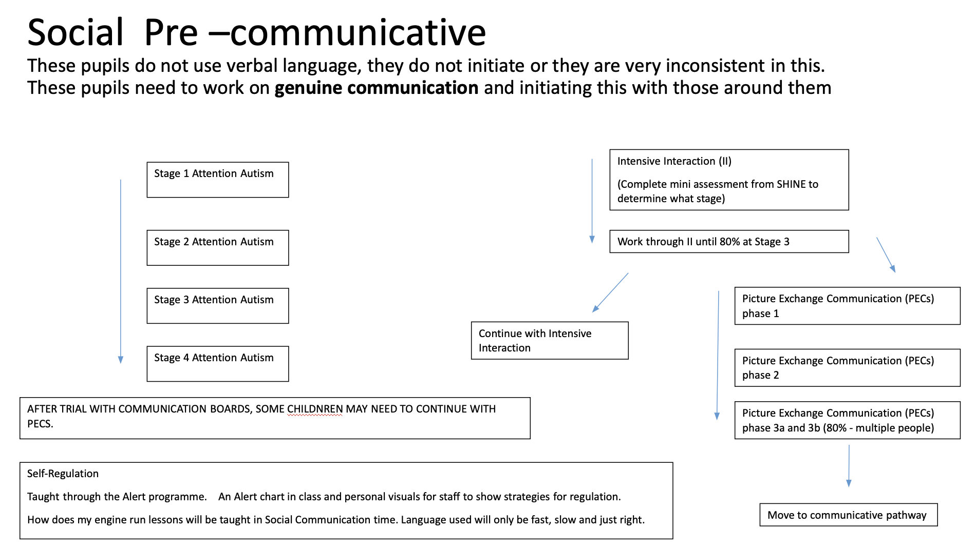
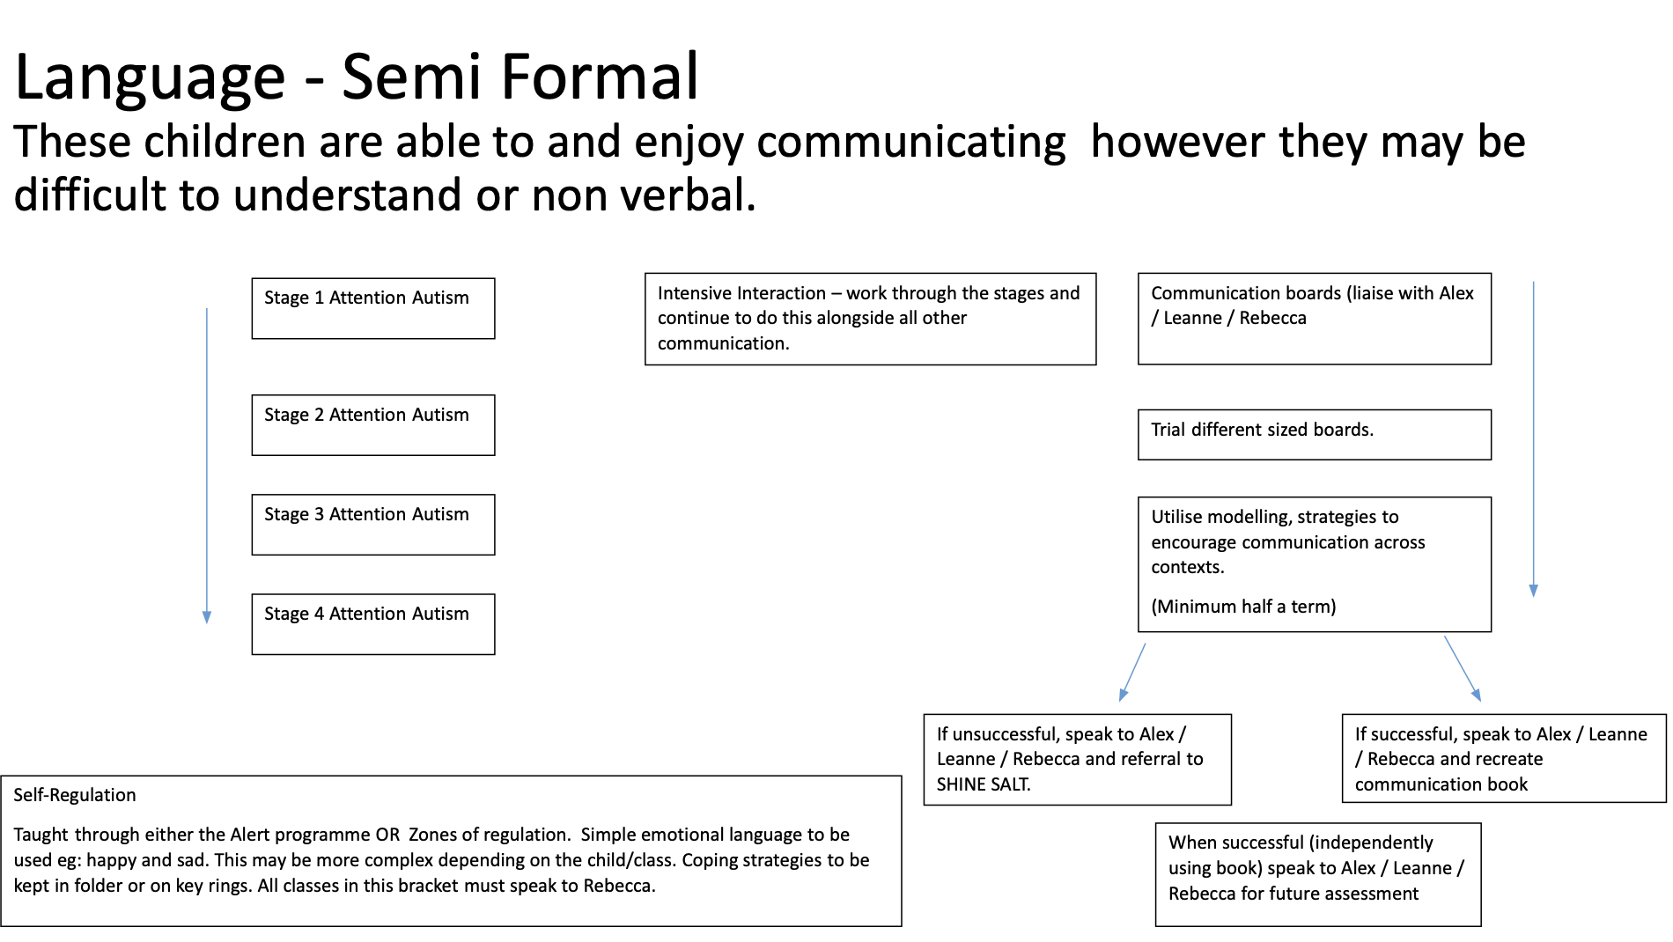
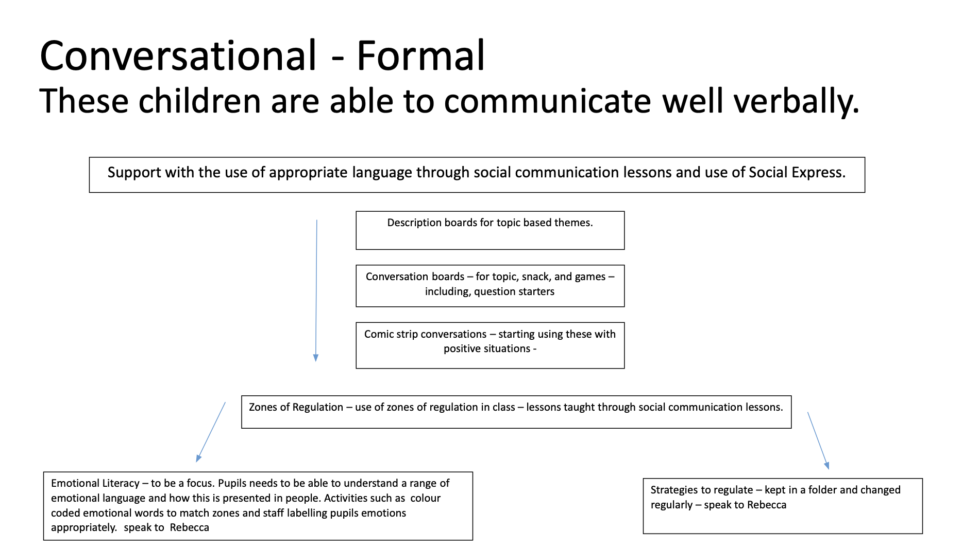

Appendix 2: AET Framework

