A RILEY
annariley@hayfield.wirral.sch.uk
Phonics policy
Policy Document 2021
Hayfield School

Contents
1 Curriculum Intent Hayfield 3
Philosophy 3
Values 3
2 Curriculum Intent: National Curriculum 4
The National Curriculum 4
Aims 4
3. Curriculum Implementation of Phonics 5
When is Phonics taught at Hayfield? 5
How is Phonics taught at Hayfield? 5
What do Pupils Learn about in Phonics 6
4 Curriculum Impact of Phonics 7
Summative Assessment 7
Formative Assessment 8
Appendix 1: Phonics Long Term Plan 9
Appendix 2: Example phonics teaching sequence 10
Appendix 3: Hayfield Summative Stages: Phonics 11

1 Curriculum Intent Hayfield

Philosophy
1.1
At Hayfield School, we work towards ‘Learning to Live and Love Life Together’. Our highest expectations inspire children to embrace learning and life as an adventure. As well as our Children reaching their highest academic potential, at Hayfield we practice a child-centred holistic approach and by Y6 our agreed cumulative goals for our children is that children at Hayfield can reach or be on a positive path to acquiring the following life skills:
- Are Confident and Independent
- Have strong Self Help Skills
- Take Responsibility for their own learning and recognise links with the outside world
- Respect themselves and others; and take Responsibility for their own behaviour and demonstrate Tolerance
- Develop Thinking skills in order to make Positive Choices
(Whole staff Inset Day 2015 – Hayfield School Values)
1.2
As well as the statutory Objectives laid out in the National Curriculum for phonics, this subject is used as a means of children achieving the following objectives:
- Inspire them to be responsible citizens
- Reflect and evaluate their learning in order to move forward
- Able to seek solutions out of problems.
- Able to share the responsibility to earn and show respect.
- Recognise rewards are on the journey, not just the destination.
- Believe in themselves

Values
1.3
The Phonics curriculum at Hayfield School is underpinned by the philosophy expounded through our values and the Goals of Education stated in Article 29 of the UN Convention of the Rights of the child. Therefore, as well as aspiring to the statutory attainment outcomes expected in the English National Curriculum 2014 we strive to develop the children’s skills relating to their creativity, emotional resilience and emotional literacy; these value include, but are not exclusive:
- Empathy
- Equality
- Happiness
- Resilience
- Gratitude
- Honest

2 Curriculum Intent: National Curriculum

The National Curriculum
2.1
English has a pre-eminent place in education and in society. A high-quality education in English will teach pupils to speak and write fluently so that they can communicate their ideas and emotions to others, and through their reading and listening, others can communicate with them. Through reading in particular, pupils have a chance to develop culturally, emotionally, intellectually, socially and spiritually. Literature, especially, plays a key role in such development. Reading also enables pupils both to acquire knowledge and to build on what they already know. All the skills of language are essential to participating fully as a member of society; pupils who do not learn to speak, read and write fluently and confidently are effectively disenfranchised.

Aims
2.1
The overarching aim for English in the national curriculum is to promote high standards of language and literacy by equipping pupils with a strong command of the spoken and written language, and to develop their love of literature through widespread reading for enjoyment. The national curriculum for English aims to ensure that all pupils:
- read easily, fluently and with good understanding
- acquire a wide vocabulary, an understanding of grammar and knowledge of linguistic conventions for reading, writing and spoken language
- write clearly, accurately and coherently, adapting their language and style in and for a range of contexts, purposes and audiences

The programme of study for EYFS framework (2021) Literacy consists of 2 dimensions:
- language comprehension
- word reading
Skilled word reading, taught later, involves both the speedy working out of the pronunciation of unfamiliar printed words (decoding) and the speedy recognition of familiar printed words. Writing involves transcription (spelling and handwriting) and composition (articulating ideas and structuring them in speech, before writing).
The programmes of study for reading at key stages 1 and 2 consist of 2 dimensions:
- word reading
- comprehension (both listening and reading)
It is essential that teaching focuses on developing pupils’ competence in both dimensions. Skilled word reading involves both the speedy working out of the pronunciation of unfamiliar printed words (decoding) and the speedy recognition of familiar printed words. Underpinning both is the understanding that the letters on the page represent the sounds in spoken words. This is why phonics should be emphasised in the early teaching of reading to beginners (i.e. unskilled readers) when they start school.

3. Curriculum Implementation of Phonics

When is Phonics taught at Hayfield?
3.2 Informal Curriculum
Pupils are taught Phonics discretely when they are working at Hayfield stage 4 (age 30-50 months) onwards. Prior to this, pupils are exposed to pre-phonics activities through sound of the week activities and by listening to stories, rhymes and songs daily.
3.3 Semi-Formal/Formal Curriculum
Pupils are taught phonics daily through either discrete Read, Write Inc. lessons or individual tasks (ISP’s). Once children access a formal curriculum, they have Read, Write Inc. lessons daily until they have completed the Read, Write Inc. programme at grey level, then pupils will move to discrete reading comprehension lessons in place of phonics.
Semi-formal classes access a daily 15-minute lesson (this may be extended as the year progresses).
Formal classes access a daily 20-30 minute lesson.

How is Phonics taught at Hayfield?
3.4
At Hayfield School phonics and initial reading skills are taught through the Read, Write Inc. programme.
Read Write Inc. Phonics teaches children to read accurately and fluently with good comprehension. They learn to form each letter, spell correctly, and compose their ideas step-by-step. Children learn the English alphabetic code: first, they learn one way to read the 40+ sounds and blend these sounds into words, then learn to read the same sounds with alternative graphemes.
Phonics is taught throughout Hayfield School, in every classroom until children reach ‘Grey’ level and move onto reading comprehension skills through Literacy Counts: Steps to Read. We focus on the phonics and reading part of the scheme, no longer using the writing elements of Read, Write Inc. as these skills are taught through Literacy Counts and Dimensions.
3.5
Teachers have access to Read, Write Inc. storybooks for each level, as well as set 1/2/3 sounds flash cards to support lessons. Copies of Read, Write Inc. writing can be accessed for use in ISP lessons when required. They also have access to online resources and additional training support through the ‘Oxford Owl’ and ‘Ruth Miskin’ websites.
3.6
Read, Write Inc. has been specifically adapted to suit the needs of the pupils in Hayfield. The programme has been slowed down to focus on the teaching of 1 individual sound and associated reading book per week. (Appendix 2: Example phonics teaching sequence).

What do Pupils Learn about in Phonics
3.5
Pupils are taught from the start of the programme how to use pure sounds, learning how to ‘Fred talk’ to orally blend and to use ‘Fred fingers’ to segment/blend sounds. Pupils will then set 1 single phoneme sounds before being introduced to set 2 (diagraph) and set 3 (split diagraph/alternative phoneme) sounds (Appendix A: Phonics long term plan).

Pupils rapidly learn sounds and the letter or groups of letters they need to represent them. Simple mnemonics help them to grasp this quickly. Pupils have frequent practice in reading high frequency words with irregular spellings – common exception words. Before they are given the opportunity to read books that are closely matched to their increasing knowledge of phonics and the common exception words. Re-reading and discussing these books with the teacher supports their increasingly fluent decoding.

In Read Write Inc. Phonics pupils:
- Decode letter-sound correspondences quickly and effortlessly, using their phonic knowledge and skills
- Read common exception words on sight
- Understand what they read
- Read aloud with fluency and expression
- Spell quickly and easily by segmenting the sounds in words

Phonics interventions
3.6
Children who have slower than average (within Hayfield) progress in phonics will have the opportunity to access 1:1 phonics interventions with our lead intervention teacher at least once a week. These pupils will continue to take part in daily phonics lesson within their class. All intervention sessions will be reviewed termly to evaluate their success and identify if they need to be continued.
3.7
We are aware that discrete phonics knowledge of decoding and blending will not be an appropriate strategy to support reading skills for some of our pupils. Pupils who have been identified as making minimal progress in phonics after year 2, will then be given the opportunity to access the Toe-by-toe programme in place of Phonics lessons.
Toe By Toe is designed for anyone who finds reading difficult. This includes weak readers who struggle to decode or those with dyslexic difficulties. Pupils are taught a phoneme using nonsense words (polynons), they then practise applying this phoneme’s rules to multi-syllabic words and reading whole sentences.
3.8
Any children with a diagnosis of Dyslexia or who are on the pathway towards being assessed for Dyslexia or with English as an additional language, also have the opportunity to access Nessy: Reading and Spelling online from home or in school during ISP sessions to further support their phonics skills.
The program begins with systematic synthetic phonics. As literacy skills develop, students advance to instruction in spelling, morphology, vocabulary and comprehension.
__________________________________________________________________________

4 Curriculum Impact of Phonics

Summative Assessment
4.
At Hayfield School, we use our own internal systems for monitoring and measuring pupil progress – Hayfield Stages (Appendix 3: Hayfield Summative Stages Phonics). These reflect statements from the Early Learning Goals and dovetail into the National Curriculum. Phonics is assessed as part of the wider reading and writing assessments. This system enables teachers to easily record, monitor and update their assessments in real-time. It makes data analysis at pupil, class and subject level possible, helps identify gaps in learning and any areas for development. (Guidance: Assessment Reporting and Recording Policy March 2021)
4.1
Using a simple grading system of E (Emerging), D (Developing), S (Secure) teachers are able to make a judgement on each pupil’s progress, taking into account the overall evidence gathered through observation, conversation, assessment and using their own professional judgement. When a child is identified as working at Secure, it would indicate that they are working at that level.
4.2
Each child’s data is collected twice a year for SLT, subject leaders and teachers to gain valuable knowledge on how the child, class and school are working in each subject.
4.3
Specific Read, Write Inc. assessments are performed at the start, mid and end of year. Children are then recorded onto a whole school Phonics document, based upon their Read, Write Inc. colour level. This helps to group pupils for their phonics lessons and identify any children making slower than average progress (within Hayfield).
4.4
Pupils in year 1 take part in the Year 1 Phonics Screening (some pupils will be dis-applied if they have no understanding of grapheme-phoneme correspondence at this point). Pupils, who do not pass the test in Year 1, repeat the test in year 2. In general, pupils in Hayfield show significant progress between the year 1 screening and re-take in year 2.
During the Phonics Screening Check, children are asked to read (decode) 40 words. Most of these words are real words but some are pseudo-words. Pseudo-words are included to ensure that children are using their decoding skills and not just relying on their memory of words they have read before.

Formative Assessment
4.5
On-going formative assessment of a child’s progress in phonics is made through reflecting on teacher’s planned learning objectives for individual lessons. Progress is recorded through annotation of work, or planning, photographs, observations and for younger classes the use of Tapestry.
Teachers are continually informally assessing pupils during their daily lessons. Ability groups may be adjusted throughout the year based upon pupil progress and teachings formative assessment.

Appendix 1: Phonics Long Term Plan

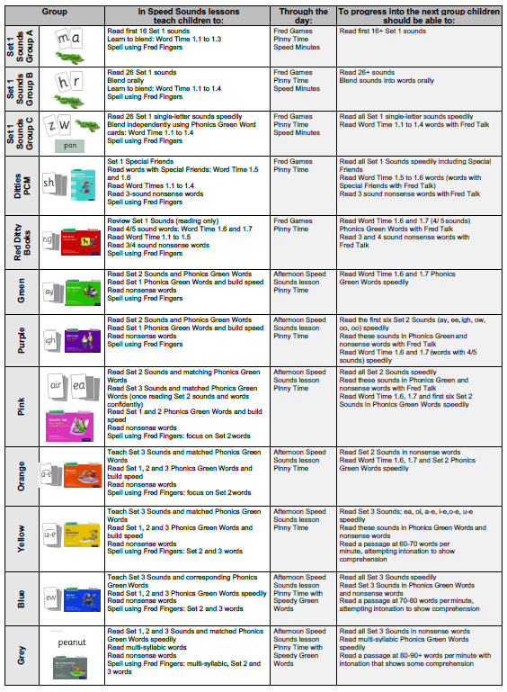

Appendix 2: Example phonics teaching sequence

MONDAY  RWI: SPEED SOUND LESSON  (follow lesson plans in speeds sounds handbook)  1. Recap on sounds learnt so far.  2. Introduce new sound (1 sound per week) – say it, read it, write it.  3. Fred talk words – practising blending.  4. Practise making words with the sound and sounds learnt so far (magnetic letters etc). | TUESDAY  RWI: WORD TIME LESSON  (follow lesson plans in speeds sounds handbook)  1. Recap on sounds learnt so far.  2. Recap on new sounds – say it, read it, write it.  Focus on teaching rhymes for the sounds.  3. Go through word time lesson – using green word cards. | WEDNESDAY  RWI: STORYBOOK TIME  1. Quick recap on sounds learnt so far.  2. Introduce the book for the sound focus this week. Recap on new sound – say it, read it, write it.  3. Discuss what the book may be about.  4. Go through vocabulary in the book and red words.  5. Introduce book (in front of book).  6. Children read the story (out loud – as groups, choral, 1 page each, 1:1 etc).  7. Teacher re-read the story with expression. | THURSDAY  RWI: STORYBOOK TIME  1. Recap on sounds learnt so far.  2. Re-read the book (out loud – as groups, choral, 1 page each, 1:1 etc) – checking for fluency.  3. Questions to talk about (ditty books) or Find it/Prove it questions (back of other reading books).  4. Consolidate knowledge of sounds and green/red words through games and activities (i.e. matching sounds, using words in sentences). | FRIDAY  RWI: RECAP AND TEST  1. Recap on sounds learnt so far.  2. Recap on new sounds, say it, read it, write it.  3. Spelling Test (linked to sounds learnt that week).

Appendix 3: Hayfield Summative Stages: Phonics

