A RILEY
annariley@hayfield.wirral.sch.uk
Reading policy
Policy Document 2021
Hayfield School

Contents
1 Curriculum Intent Hayfield 4
Philosophy 4
Values 4
2 Curriculum Intent: National Curriculum 5
The National Curriculum 5
Aims 5
3. Curriculum Implementation of Reading 6
When is Reading taught at Hayfield? 6
How is Reading taught at Hayfield? 6
What do Pupils Learn about in Reading 7
Reading for Pleasure Agenda 8
4 Curriculum Impact of Reading 9
Summative Assessment 9
Formative Assessment 10
Appendix 1: English long term plan 11
Appendix 2: VIPERS content domains 12
Appendix 3a: Reading links within Dimensions LMTW – New EYFS Framework 13
14
Appendix 3b: Dimensions skills ladder – Explorers 15
Appendix 3c: Dimensions reading opportunities 15
Appendix 4: Hayfield Summative Stages – Reading 17

1 Curriculum Intent Hayfield

Philosophy
1.1
At Hayfield School, we work towards ‘Learning to Live and Love Life Together’. Our highest expectations inspire children to embrace learning and life as an adventure. As well as our Children reaching their highest academic potential, at Hayfield we practice a child-centred holistic approach and by Y6 our agreed cumulative goals for our children is that children at Hayfield can reach or be on a positive path to acquiring the following life skills:
- Are Confident and Independent
- Have strong Self Help Skills
- Take Responsibility for their own learning and recognise links with the outside world
- Respect themselves and others; and take Responsibility for their own behaviour and demonstrate Tolerance
- Develop Thinking skills in order to make Positive Choices
(Whole staff Inset Day 2015 – Hayfield School Values)
1.2
As well as the statutory Objectives laid out in the National Curriculum for Reading, this subject is used as a means of children achieving the following objectives:
- Inspire them to be responsible citizens
- Reflect and evaluate their learning in order to move forward
- Able to seek solutions out of problems.
- Able to share the responsibility to earn and show respect.
- Recognise rewards are on the journey, not just the destination.
- Believe in themselves

Values
1.3
The Reading curriculum at Hayfield school is underpinned by the philosophy expounded through our values and the Goals of Education stated in Article 29 of the UN Convention of the Rights of the child. Therefore, as well as aspiring to the statutory attainment outcomes expected in the Computing National Curriculum 2014 (Table 1) we strive to develop the children’s skills relating to their creativity, emotional resilience and emotional literacy; these value include, but are not inclusive:
- Empathy
- Equality
- Happiness
- Resilience
- Gratitude
- Honest

2 Curriculum Intent: National Curriculum

The National Curriculum
2.1
The EYFS framework (2021) for Literacy consists of 2 dimensions:
- language comprehension
- word reading.

Language comprehension (necessary for both reading and writing) starts from birth. It only develops when adults talk with children about the world around them and the books (stories and non-fiction) they read with them, and enjoy rhymes, poems and songs together. Skilled word reading, taught later, involves both the speedy working out of the pronunciation of unfamiliar printed words (decoding) and the speedy recognition of familiar printed words.
The programmes of study for reading at key stages 1 and 2 consist of 2 dimensions:

- word reading
- comprehension (both listening and reading)

It is essential that teaching focuses on developing pupils’ competence in both dimensions; different kinds of teaching are needed for each.
Skilled word reading involves both the speedy working out of the pronunciation of unfamiliar printed words (decoding) and the speedy recognition of familiar printed words. Underpinning both is the understanding that the letters on the page represent the sounds in spoken words. This is why phonics should be emphasised in the early teaching of reading to beginners (i.e. unskilled readers) when they start school.
Good comprehension draws from linguistic knowledge (in particular of vocabulary and grammar) and on knowledge of the world. Comprehension skills develop through pupils’ experience of high-quality discussion with the teacher, as well as from reading and discussing a range of stories, poems and non-fiction. All pupils must be encouraged to read widely across both fiction and non-fiction to develop their knowledge of themselves and the world they live in, to establish an appreciation and love of reading, and to gain knowledge across the curriculum. Reading widely and often increases pupils’ vocabulary because they encounter words they would rarely hear or use in everyday speech. Reading also feeds pupils’ imagination and opens up a treasure house of wonder and joy for curious young minds.
It is essential that, by the end of their primary education, all pupils are able to read fluently, and with confidence, in any subject in their forthcoming secondary education.

Aims
2.1
The overarching aim for English in the national curriculum is to promote high standards of language and literacy by equipping pupils with a strong command of the spoken and written language, and to develop their love of literature through widespread reading for enjoyment. The national curriculum for reading aims to ensure that all pupils:
- read easily, fluently and with good understanding
- develop the habit of reading widely and often, for both pleasure and information
- acquire a wide vocabulary, an understanding of grammar and knowledge of linguistic conventions for reading, writing and spoken language
- appreciate our rich and varied literary heritage

3. Curriculum Implementation of Reading

When is Reading taught at Hayfield?
3.1 Informal curriculum
Pupils working on the informal EYFS curriculum listen to daily stories within class and have opportunities to act out, discuss and join in with stories through the Dimensions continuous provision curriculum and daily class story time.
Every day pupils work towards their English ISP targets 1:1 with an adult; these vary between reading and writing activities depending on the pupil. Each class has a rhyme of the week, linked to their topic theme, introducing a variety of poetry, rhymes and repetitive stories to the children. Each week there is an adult led and continuous provision activity focused on reading and/or writing.
3.2 Semi-Formal curriculum/Formal curriculum
Pupils have daily Read, Write Inc. lessons or Literacy Counts: Steps to Read lessons in which reading and comprehension skills are explicitly taught.
Pupils access at least 2-3 weekly Literacy Counts: Read to Write lessons a week, in which reading skills are practised and extended through discussion and analysis of texts.
Pupils are listened to reading 1:1 with an adult with phonetically decodable books for their ability at least once a week, with an aim of twice a week where possible. Comprehensions skills are then developed through VIPERS questioning by the adult.
Pupils listen to a whole class story several times a week, to allow opportunities for age appropriate texts that may be above pupils individual reading abilities to be accessed.

How is Reading taught at Hayfield?
3.3 Read Write Inc.
Pupils working at Stage 5 and above are taught initial reading skills through daily Read, Write Inc. phonics lessons and activities.
Read Write Inc. Phonics is taught throughout Hayfield School, in every classroom until children reach ‘Grey’ level and move onto reading comprehension skills through Literacy Counts: Steps to Read. (See Phonics policy 2021 for more information)
4.1 Literacy Counts: Steps to Read
Children who have completed Read, Write Inc. and are able to read without overtly blending or decoding, will then move onto group reading comprehension skills using Literacy Count’s Steps to Read. Steps to Read is planning support for whole class/group shared reading through carefully crafted units of work.
4.2 Literacy Counts: Read to Write
Pupils accessing a semi-formal/formal curriculum will access alternative reading opportunities through the Literacy Counts: Read to Write curriculum. These lessons are taught at least 3 times a week and allow pupils the opportunity to immerse themselves and analyse vocabulary-rich texts, gaining knowledge on a variety of text structures and language features. (See Writing policy 2021 for more information).
4.3 Dimensions
Pupils across the school also have access to cross-curriculum reading opportunities through the Dimensions: Learning means the world curriculum.

What do Pupils Learn about in Reading
4.4 Read Write Inc.
Read Write Inc. Phonics teaches children to read accurately and fluently with good comprehension. They learn to form each letter, spell correctly, and compose their ideas step-by-step. Children learn the English alphabetic code: first, they learn one way to read the 40+ sounds and blend these sounds into words, then learn to read the same sounds with alternative graphemes.
4.5 Steps to Read
The primary aim of Steps to Read is to teach reading comprehensions skills and strategies explicitly. It teaches all aspects of word reading and comprehension through high-quality fiction, non-fiction and poetry texts.
4.4 VIPERS
1:1 and whole-class reading comprehension is supported using the VIPERS approach. VIPERS is an acronym to aid the recall of the 6 reading domains as part of the UK’s reading curriculum. They are the key areas which we feel children need to know and understand in order to improve their comprehension of texts. VIPERS stands for:
Vocabulary
Inference
Prediction
Explanation
Retrieval
Sequence or Summarise

The 6 domains focus on the comprehension aspect of reading and not the mechanics: decoding, fluency, prosody etc. As such, VIPERS is not a reading scheme but rather a method of ensuring that teachers ask, and students are familiar with, a range of questions. They allow the teacher to track the type of questions asked and the children’s responses to these, which allows for targeted questioning afterwards.

At Hayfield, we have a KS1 and KS2 reading records based upon the different levels of VIPERS questions (Appendix 2: VIPERS content domains) that are used for all pupils accessing semi-formal/formal curriculums. VIPERS questioning is then embedded within the curriculum and used during other reading opportunities.

4.5 Dimensions: Learning means the world
Learning Means the World is planned around a Skills Ladder, giving a clear upward trajectory of subject-specific, skills-based learning (Appendix 3b: Dimensions skills ladder).
Pupils accessing an informal curriculum (also known as Explorers 1) access reading opportunities within Learning means the world through continuous provision activities and 1:1 activities with an adult.
Pupils accessing a semi-formal (also known as Explorers 2) and a formal (also known as Pathfinders or Adventurers) curriculum may take part in some of the cross-curricular reading activities including in the Learning means the world planning (Appendix 3c: Dimensions reading opportunities).
4.6 Literacy Counts: Read to Write
Read to Write: Foundations resources follow a common sequence: Jump in, Look, Plan sentences, Write sentences. Read to Write: National Curriculum resources follow a similar sequence with progression: Immerse, Analyse, Plan and Write. The ‘Jump in’ and ‘Immerse’ sections of both planning units offers a wider variety of reading opportunities and teaches specific reading skills, such as predicting, making inferences and dictionary work. It allows the pupils to immerse themselves in the text, having opportunities to explore and respond to it. Pupils learn how to determine the purpose, audience and form of the story, whilst having opportunities for drama and spoken language links.

Reading for Pleasure Agenda

Due to our students varying needs, children may be reading fluently at a level significantly below age expected, therefore we have ensured we have a strong reading for pleasure motivation across the school, to ensure all pupils are still seeing/hearing/sharing age appropriate texts and developing a love for reading.

4.6 Library organisation
Our library is divided into 3 sections:
- Banded Books: All phonetically decodable books have been colour coded in line with the Read, Write Inc. phonics scheme – children should only read books which contain sounds taught so far. These books will be used for 1:1 reading and reading assessment.
- Shared Reading Books: These books are from schemes not in line with Read, Write Inc. – we have kept these books to be used as part of shared reading activities with an adult and to give a wider variety of texts.
- Reading for Pleasure: A large section of our library is dedicated to reading for pleasure books. Children can choose to read/look at these books regarding of their reading ability. All books are colour coded by genre to support the children’s independence whilst using the library. This is also supported by our ‘Hayfield Reading Challenge’.

4.7 Hayfield Reading Challenge

The ‘Hayfield Reading Rail Challenge’ has been created to motivate the children to pick up and read a variety of texts across different genres and by different authors. Each station on the local rail map is assigned a book, each section of the rail line is assigned a different genre/author and we have two different train lines to choose from based on ability. Children receive certificates and prizes for completing different sections. The challenge is updated yearly.

4.8 Literacy Spine
The Hayfield Literacy Spine has been created for each stage of the school in line with the Dimensions stages. The texts on the Literacy Spine are recommended core reads per Hayfield Curriculum stage, based upon the curriculum links, big questions, core values and teachings per year group, alongside providing and ensuring children develop a lifelong enjoyment of reading, with access to a wide range of texts. These books can be read independently by the children or read as a whole class text.

The Literacy Spine is separated into 4 sections to link in with our wider curriculum:

- Dimensions: This section is created to ensure that children engage with reading around their topic, and includes a variety of fiction and non-fiction texts to ensure deeper learning. Dimensions units cover global issues, as well as citizenship and British Values.
- Social skills: A variety of their texts to support understanding of social skills and to experience it from different perspectives (This is incorporated into the wider reading section for children working above Explorers 1).
- Literacy Counts: A collection of texts based around the core Literacy Counts text for the term. All with similar themes or features. Giving opportunities to consolidate knowledge of writing features and layout structures (Not applicable for Explorers 1).
- Wider Reading: These texts provide opportunities for the pupils to engage in discussions, as well as introduce key global issues. Exposing the pupils to prize winning texts, key authors and fostering a love for all genres of writing, whilst addressing topics linked to PHSE, RSE, British Values and Cultural Diversity.

4.9 Oxford Owl
Teachers and pupils have access to Oxford Owl online library, which includes phonetically decodable and levelled books for all abilities. Pupils can also access this library from home.

4 Curriculum Impact of Reading

Summative Assessment
4.
At Hayfield School, we use our own internal systems for monitoring and measuring pupil progress – Hayfield Stages. Hayfield Stages for reading can be found in Appendix 4. (Appendix 4: Hayfield Summative Stages Reading). These reflect statements from the Early Learning Goals and dovetail into the National Curriculum. This system enables teachers to easily record, monitor and update their assessments in real-time. It makes data analysis at pupil, class and subject level possible, helps identify gaps in learning and any areas for development. (Guidance: Assessment Reporting and Recording Policy March 2021)
4.1
Using a simple grading system of E (Emerging), D (Developing), S (Secure) teachers are able to make a judgement on each pupil’s progress, taking into account the overall evidence gathered through observation, conversation, assessment and using their own professional judgement. When a child is identified as working at Secure, it would indicate that they are working at that level.
4.2
Each child’s data is collected twice a year for SLT, subject leaders and teachers to gain valuable knowledge on how the child, class and school are working in each subject.
4.3
Work and reading records for Reading are monitored as part of the whole school plan for monitoring teaching and learning.
4.4
Pupils who are able to blend CVC words are baselined at the start of each academic year and then re-assessed for their annual review mid-way through the year in reading using the New Salford sentence-reading test. This test gives teachers a reading age, alongside a National Curriculum reading and comprehension level.
4.5
Pupils are assessed on their phonics and decoding skills twice a year using Read, Write Inc. assessments (see Phonics policy 2021 for more detail).

Formative Assessment
4.4
On-going formative assessment of a child’s progress in Writing is made through reflecting on teacher’s planned learning objectives for individual lessons. Progress is recorded through annotation of work, or planning, photographs, observations and for younger classes the use of Tapestry

Appendix 1: English long term plan

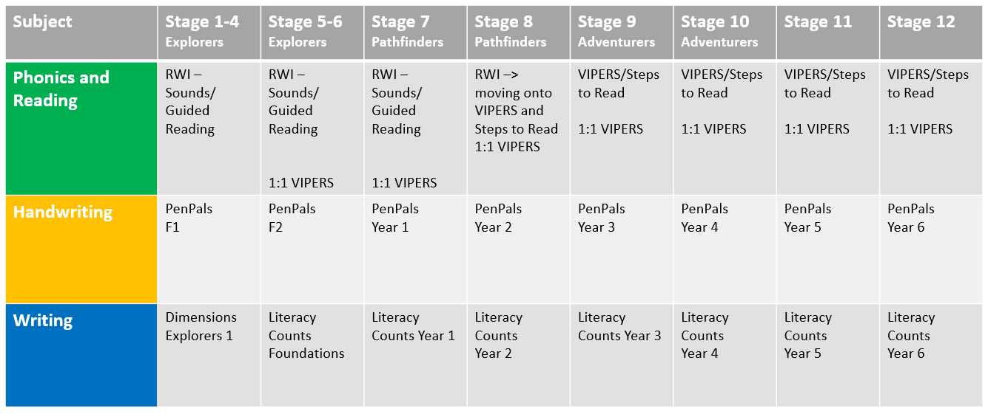
*Pupils may be working at different stages for each area of the English Curriculum

Appendix 2: VIPERS content domains

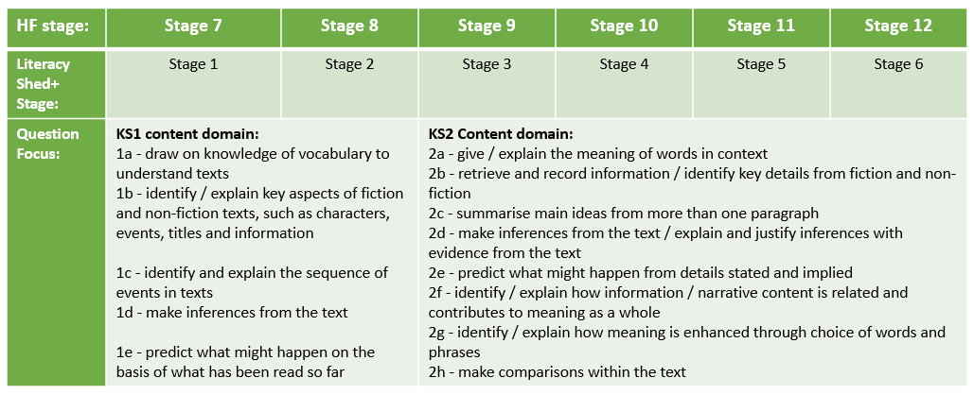

Appendix 3a: Reading links within Dimensions LMTW – New EYFS Framework
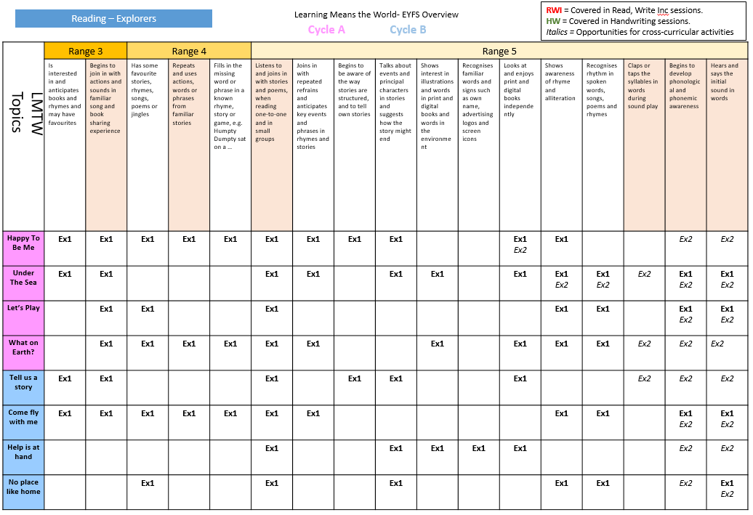

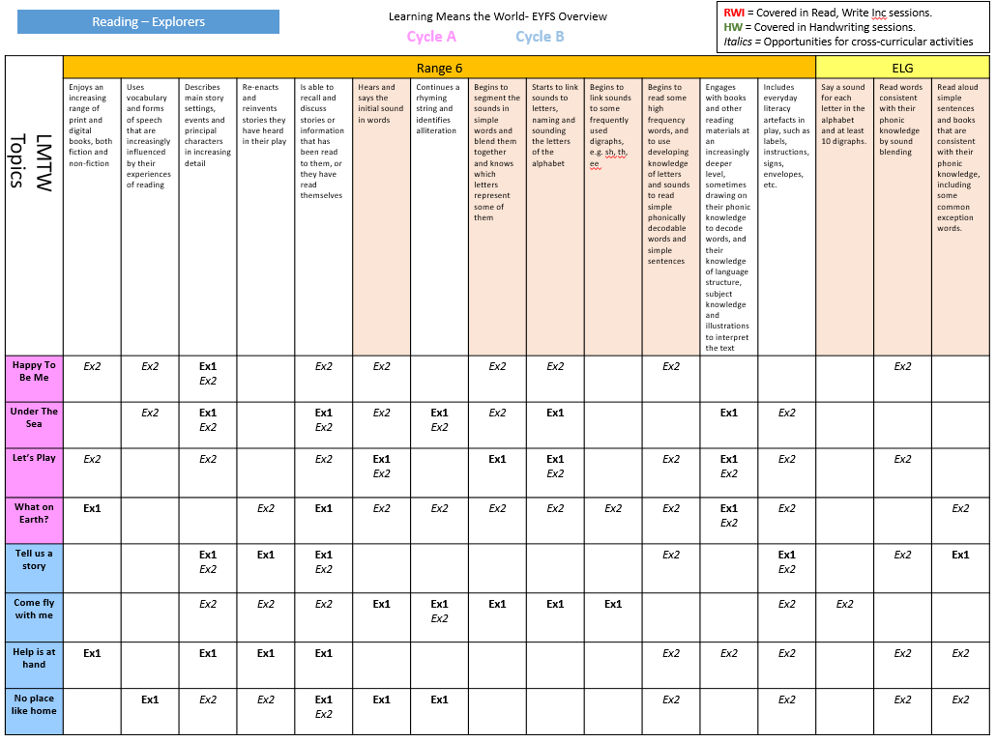

Appendix 3b: Dimensions skills ladder – Explorers

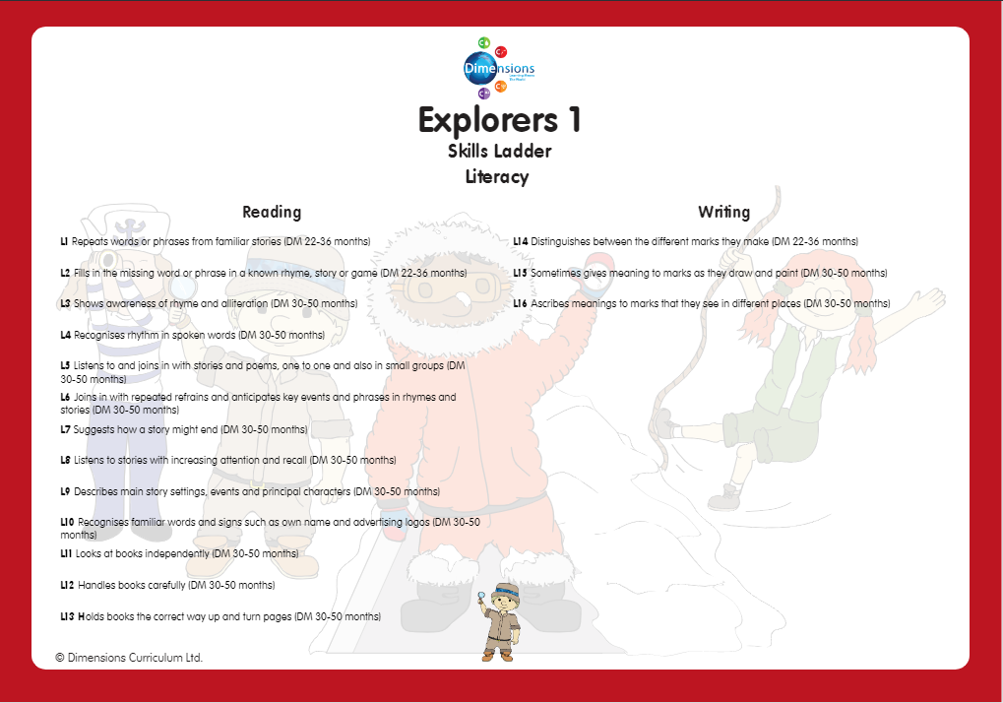
Appendix 3c: Dimensions reading opportunities
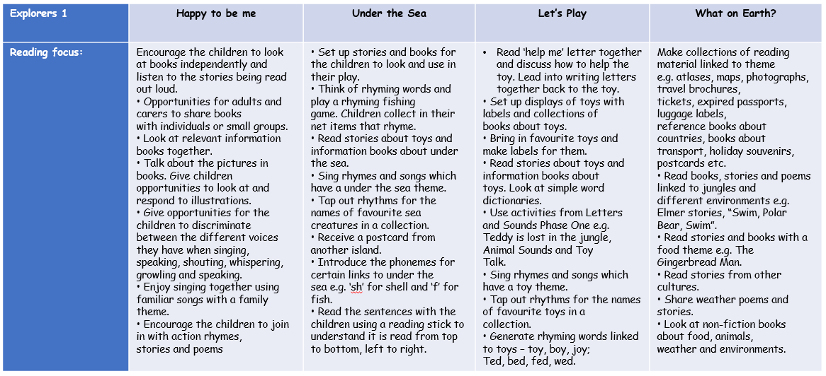
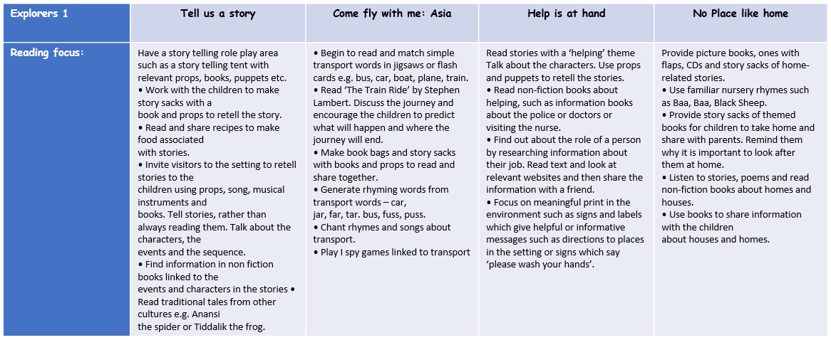

Appendix 4: Hayfield Summative Stages – Reading
