A RILEY
annariley@hayfield.wirral.sch.uk
ENGLISH/WRITING POLICY
Policy Document 2021
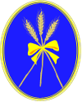
Hayfield School

Contents
1 Curriculum Intent Hayfield 3
Philosophy 3
Values 3
2 Curriculum Intent: National Curriculum 4
The National Curriculum 4
Aims 4
3. Curriculum Implementation of Writing 5
When is Writing taught at Hayfield? 5
How is Writing taught at Hayfield? 5
What do Pupils Learn about in Writing 7
4 Curriculum Impact of Writing 9
Summative Assessment 9
Formative Assessment 9
Appendix 1a: English Long Term Plan 7
Appendix 1b: Writing Long Term Plan 8
Appendix 1c: Literacy Counts Additional Units 9
Appendix 2a: Writing links within Dimensions LMTW – New EYFS Framework 10
Appendix 2b: Dimensions skills ladders 12
Appendix 2c: Dimensions writing opportunities 12
Appendix 3a: Literacy Counts Curriculum Coverage – Writing 13
Appendix 4: Hayfield Summative Stages - Writing 17

1 Curriculum Intent Hayfield

Philosophy
1.1
At Hayfield School, we work towards ‘Learning to Live and Love Life Together’. Our highest expectations inspire children to embrace learning and life as an adventure. As well as our Children reaching their highest academic potential, at Hayfield we practice a child-centred holistic approach and by Y6 our agreed cumulative goals for our children is that children at Hayfield can reach or be on a positive path to acquiring the following life skills:
- Are Confident and Independent
- Have strong Self Help Skills
- Take Responsibility for their own learning and recognise links with the outside world
- Respect themselves and others; and take Responsibility for their own behaviour and demonstrate Tolerance
- Develop Thinking skills in order to make Positive Choices
(Whole staff Inset Day 2015 – Hayfield School Values
1.2
As well as the statutory Objectives laid out in the National Curriculum for Writing, this subject is used as a means of children achieving the following objectives:
- Inspire them to be responsible citizens
- Reflect and evaluate their learning in order to move forward
- Able to seek solutions out of problems.
- Able to share the responsibility to earn and show respect.
- Recognise rewards are on the journey, not just the destination.
- Believe in themselves

Values
1.3
The Writing curriculum at Hayfield school is underpinned by the philosophy expounded through our values and the Goals of Education stated in Article 29 of the UN Convention of the Rights of the child. Therefore, as well as aspiring to the statutory attainment outcomes expected in the Writing National Curriculum 2014 (Table 1) we strive to develop the children’s skills relating to their creativity, emotional resilience and emotional literacy; these value include, but are not exclusive:
- Empathy
- Equality
- Happiness
- Resilience
- Gratitude
- Honest

2 Curriculum Intent: National Curriculum

The National Curriculum
2.1
English has a pre-eminent place in education and in society. A high-quality education in English will teach pupils to speak and write fluently so that they can communicate their ideas and emotions to others and through their reading and listening, others can communicate with them. Through reading in particular, pupils have a chance to develop culturally, emotionally, intellectually, socially and spiritually. Literature, especially, plays a key role in such development. Reading also enables pupils both to acquire knowledge and to build on what they already know. All the skills of language are essential to participating fully as a member of society; pupils, therefore, who do not learn to speak, read and write fluently and confidently are effectively disenfranchised.

Aims
2.1
The overarching aim for English in the national curriculum is to promote high standards of language and literacy by equipping pupils with a strong command of the spoken and written word, and to develop their love of literature through widespread reading for enjoyment.
The national curriculum for Writing aims to ensure that all pupils:
- acquire a wide vocabulary, an understanding of grammar and knowledge of linguistic conventions for reading, writing and spoken language
- appreciate our rich and varied literary heritage
- write clearly, accurately and coherently, adapting their language and style in and for a range of contexts, purposes and audiences
- use discussion in order to learn; they should be able to elaborate and explain clearly their understanding and ideas
- are competent in the arts of speaking and listening, making formal presentations, demonstrating to others and participating in debate.
The programmes of study for writing at key stages 1 and 2 are constructed similarly to those for reading:
- transcription (spelling and handwriting)
- composition (articulating ideas and structuring them in speech and writing).

It is essential that teaching develops pupils’ competence in these two dimensions. In addition, pupils should be taught how to plan, revise and evaluate their writing.
Writing down ideas fluently depends on effective transcription: that is, on spelling quickly and accurately through knowing the relationship between sounds and letters (phonics) and understanding the morphology (word structure) and orthography (spelling structure) of words. Effective composition involves forming, articulating and communicating ideas, and then organising them coherently for a reader. This requires clarity, awareness of the audience, purpose and context, and an increasingly wide knowledge of vocabulary and grammar. Writing also depends on fluent, legible and, eventually, speedy handwriting.

3. Curriculum Implementation of Writing

When is Writing taught at Hayfield?
3.1 Informal curriculum
Every day pupils work towards their English ISP targets 1:1 with an adult; these vary between reading and writing activities depending on the pupil.
Each week there is an adult led and continuous provision activity focused on reading and/or writing.
Children practise letter formation through the PenPals handwriting activities during continuous provision (see Handwriting policy 2021) and phonics/spelling through Read, Write Inc. activities if working at stage 4 or above (See Phonics policy 2021).

3.2 Semi-Formal/Formal Curriculum
Pupils accessing a semi-formal or formal curriculum have discrete English lessons, focused on a writing end goal. These lessons are taught 2-4 times a week depending on the curriculum level. Opportunities for cross-curriculum writing are also available during Dimensions: Learning Means the World topic lessons 3 times a week.

How is Writing taught at Hayfield?

3.3 Dimensions: Learning means the world
Learning Means the World is a cross-curricular thematic approach to teaching and learning is designed to support children’s natural curiosity, stimulate their creativity and promote an appetite for, and love of, learning. It offers children the chance to engage in deep learning giving them the time they need to reflect, consolidate and transfer their learning.
All pupils in Hayfield access Learning means the world for cross-curricular writing opportunities. However, pupils accessing an informal curriculum will be taught Writing primarily through Learning Means the World, by embedding writing opportunities within their continuous provision topic based activities.

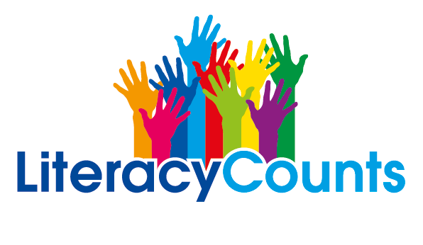
3.4 Literacy Counts
At Hayfield School, discrete English lessons are taught within the semi-formal and formal curriculum through our Literacy Counts: Read to Write scheme. Read to Write empowers teachers to provide high-quality teaching of writing through children’s high-quality literature (Vehicle Texts). The units of work centre on engaging, vocabulary-rich texts, with a wealth of writing opportunities. All units offer cross-curricular opportunities with Science, Geography or History.
Pupils accessing a semi-formal curriculum follow the Read to write: Foundations units, these units have been constructed against the reformed Early Years Foundation Stage Curriculum and Development Matters 2021. They have an emphasis on providing practical ways for young children to engage, explore and enjoy communicating through writing at their individual stage of development.
Pupils accessing a formal curriculum follow the National Curriculum Read to Write units, based upon teacher assessment of their ability. Pupils will work on units suited to their academic ability, rather than their age.
Read to Write is a mainstream scheme of work, which allows 1 unit per half term. At Hayfield we have adapted their proposed curriculum to a pace more suited for our pupils varying needs, completing 1 unit per academic term.
We have also incorporated the ‘additional texts’ provided by Literacy Counts into our long-term plan, to allow for additional time for the cohorts that require it. Pupils generally progress through Literacy counts at a rate of one national curriculum year of progress, per two academic years, but there is the option of extending this to over three years using the additional texts (Appendix 1a: English long term plan and 1b: Writing long term plan).
Read to Write has also been mapped out to provide cross-curricular links with all Dimensions topics. Teachers are encouraged to support pupils to write an ‘end goal’ final piece of writing in line with the Literacy Counts unit, and to then use these skills to write an additional final piece linked with the Dimensions topic the pupils are currently studying.
3.5 PenPals
Handwriting is taught through the PenPals for handwriting scheme. PenPals is a complete handwriting scheme for 3-11 year olds that provides a clear progression through five developmental stages; beginning to join along, securing the joins and practising speed, fluency and developing a personal style. (See Handwriting Policy 2021 for more detail).
Handwriting skills are then continually practised throughout the daily curriculum, with pupils using books with lines of the same size to their handwriting books, as well as other supporting strategies such as prompt stickers for presentation, highlighter to support writing on the line and letter sizing and tilted writing boards when required.
3.6 Read Write Inc.
At Hayfield School phonics and initial reading skills are taught through the Read, Write Inc. programme. Read Write Inc. Phonics teaches children to read accurately and fluently with good comprehension. Children learn the English alphabetic code: first, they learn one way to read the 40+ sounds and blend these sounds into words, then learn to read the same sounds with alternative graphemes (See Phonics Policy 2021 for more detail).
These phonics skills are then continually practised throughout the daily curriculum, with pupils being supported to remember sounds by their Read Write Inc. rhymes and blend using ‘Fred fingers’ when writing spellings.
3.7 Colourful Semantics
Colourful semantics is an approach created by Alison Bryan. It is aimed at helping children to develop their grammar but it is rooted in the meaning of words (semantics). Colourful semantics reassembles sentences by cutting them up into their thematic roles and then colour codes them.
The approach has 4 key colour coded stages. There are further stages for adverbs, adjectives, conjunctions and negatives.
- WHO – Orange
- WHAT DOING – Yellow
- WHAT – Green
- WHERE – Blue
Colourful semantics is embedded throughout the school; primarily in the younger classes to aid language and speech, before being used to aid writing as the pupil’s progress. It is used alongside the entire curriculum, including in classroom visuals and communication books.

3.8 Colourful Stories
Colourful Stories is a visual support strategy that helps children to learn about the structure of stories and become more confident about telling and writing stories. Colourful Stories encourages oral narrative sills and introduces written words only when the child is confident about the structure of a story and how to tell a story orally.
Colourful Stories consists of 6 colour coded visuals/cards to represent the different parts of a story and story sequencing cards. These have been adapted at Hayfield to link in with Colourful Semantics colours and Read to Write: Foundations story friends.
Colourful Stories is used with pupils accessing a semi-formal/formal curriculum as additional support for Read to Write, although the visuals and flash cards may be introduced and used within classes assessing the informal curriculum when appropriate.

What do Pupils Learn about in Writing

3.9 Dimensions: Learning means the world
Learning Means the World is planned around a Skills Ladder, giving a clear upward trajectory of subject-specific, skills-based learning (Appendix 2b: Dimensions skills ladders).
Pupils accessing an informal curriculum (also known as Explorers 1) access writing opportunities within Learning means the world through continuous provision activities and 1:1 activities with an adult.
Pupils accessing a semi-formal (also known as Explorers 2) and a formal (also known as Pathfinders or Adventurers) curriculum may take part in some of the cross-curricular writing activities including in the Learning means the world planning. However do not follow the ‘Literacy’ element of Learning means the world – this is covered by the Literacy Counts curriculum, and the cross-curricular opportunities linked to the Literacy Counts end goals.
3.10 Read to Write: Foundations
Read to Write: Foundations resources follow a common sequence: Jump in, Look, Plan sentences, Write sentences. This is based on a tried and tested model (UKLA and Primary National Strategy, 2004) and acknowledges the strong interrelationship between speaking and listening, reading and writing, as well as creating a familiar structure for Read to Write National Curriculum units in the future. This familiar structure allows our pupils to grow in confidence as they master the learning sequence and planning structures.
- Jump in: Immersion in the text, opportunities to explore and respond to the text. Determine the purpose, audience and form. Focus on reading skills. Opportunities for drama and spoken language links.
- Look: Familiarisation with word, sentence and text structures. Familiarisation with language features (GPaS links). Learn new writing skills.
- Plan sentences: Sentence planning (GPaS links). Circular story planning.
- Write sentences: Shared and guided writing opportunities. Sentence application of new skills. Sentence oracy and editing. Opportunities for continuous provision writing.

Read to Write Foundations has two main writing outcomes per unit; story sentences and non-fiction sentences (Appendix 1b: Writing long-term plan).

For the story sentences there are 4 story friends which help children identify different parts of a simple stories. They support children’s understanding of how stories work by looking at 4 story elements. They are as follows:
• Octopus Opening
• Build Up Bear
• Penguin Problem
• Elephant Ending
They are ‘best’ friends and together help us understand how stories work. They each listen and look at different parts of stories. They love to help children retell parts of story sentences to help them understand.

3.11 Read to Write: National Curriculum
Read to Write resources follow a common sequence: Immerse, Analyse, Plan and Write. This is based on a tried and tested model (UKLA and Primary National Strategy, 2004) and acknowledges the strong interrelationship between speaking and listening, reading and writing.
- Immerse: Immersion in the text, opportunities to explore and respond to the text. Determine the purpose, audience and form. Focus on reading skills. Opportunities for drama and spoken language links.
- Analyse: Familiarisation with text structure and language features (GPaS links). Learn new writing skills.
- Plan: Gather ideas and plan.
- Write: Application of writer’s skills and knowledge. Draft, revise and edit own writing.

Each unit of work is based around two specific writing purposes; one will be a narrative outcome, the other will vary between recount/instructions/information depending on the text. Ensuring the pupils have a wealth of opportunity for writing different genres (Appendix 1b: Writing long-term plan).

4 Curriculum Impact of Writing

Summative Assessment
4.
At Hayfield School, we use our own internal systems for monitoring and measuring pupil progress – Hayfield Stages (Appendix 4: Hayfield Summative Stages Writing). These reflect statements from the Early Learning Goals and dovetail into the National Curriculum. This system enables teachers to easily record, monitor and update their assessments in real-time. It makes data analysis at pupil, class and subject level possible, helps identify gaps in learning and any areas for development. (Guidance: Assessment Reporting and Recording Policy March 2021)
4.1
Using a simple grading system of E (Emerging), D (Developing), S (Secure) teachers are able to make a judgement on each pupil’s progress, taking into account the overall evidence gathered through observation, conversation, assessment and using their own professional judgement. When a child is identified as working at Secure, it would indicate that they are working at that level.
4.2
Each child’s data is collected twice a year for SLT, subject leaders and teachers to gain valuable knowledge on how the child, class and school are working in each subject.
4.3
Work in English/Writing is monitored as part of the whole school plan for monitoring teaching and learning.

Formative Assessment
4.4
On-going formative assessment of a child’s progress in Writing is made through reflecting on teacher’s planned learning objectives for individual lessons. Progress is recorded through annotation of work, or planning, photographs, observations and for younger classes the use of Tapestry.

Appendix 1a: English Long Term Plan

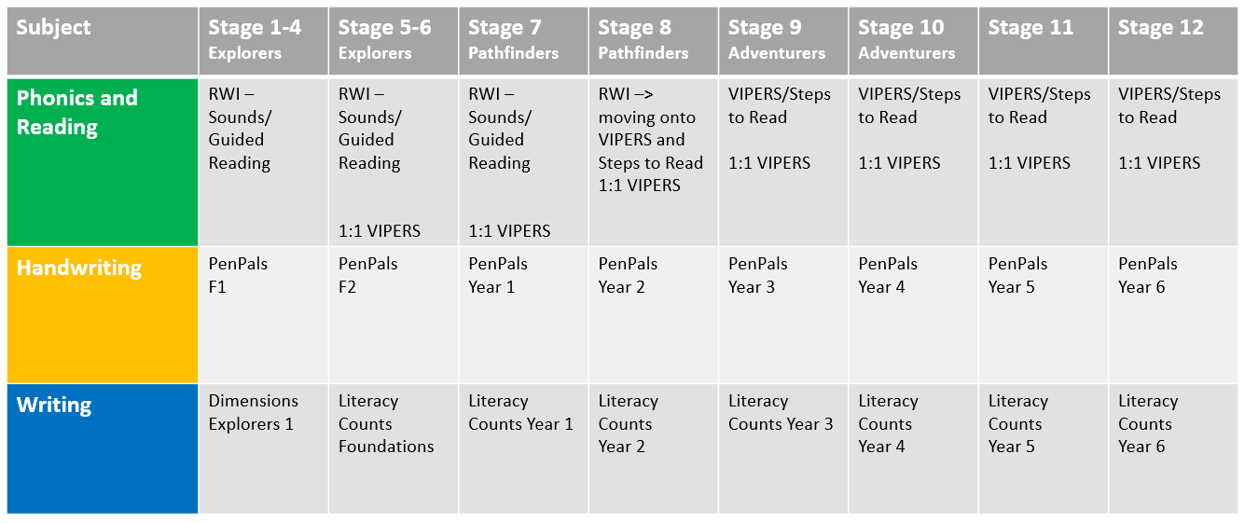
* Pupils may be working at different stages for each area of the English Curriculum

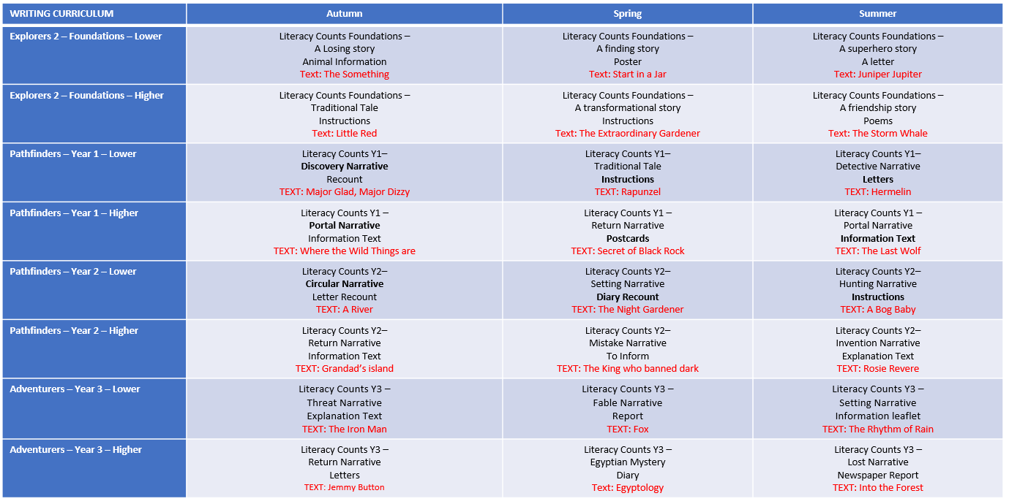
Appendix 1b: Writing Long Term Plan

Appendix 1c: Literacy Counts Additional Units

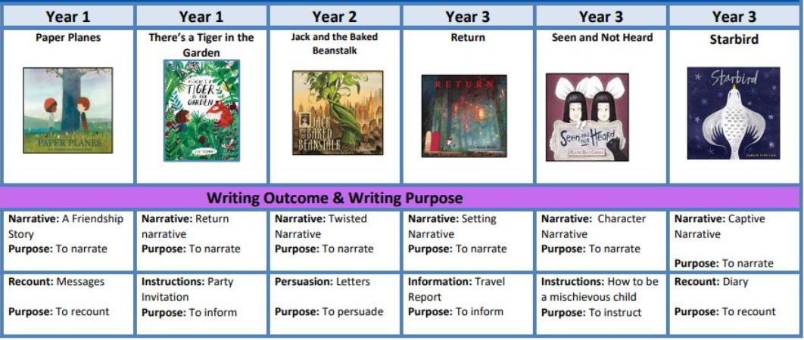

Appendix 2a: Writing links within Dimensions LMTW – New EYFS Framework
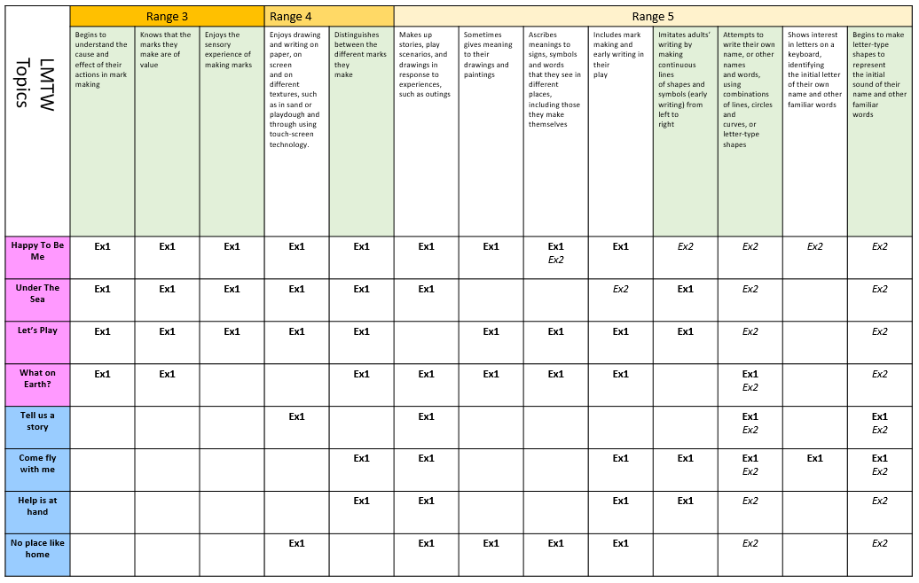
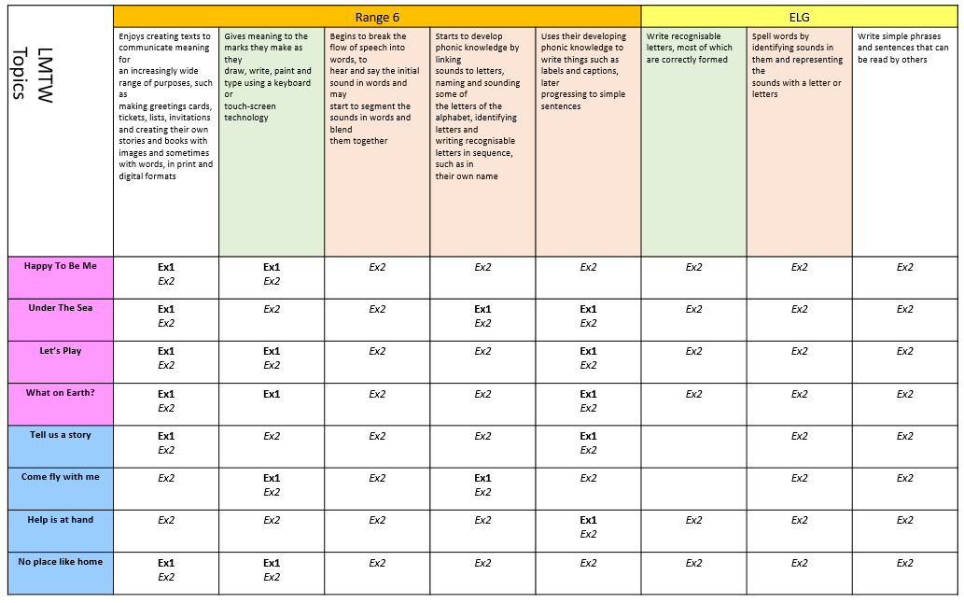
RWI = Covered in Read, Write Inc. sessions.
HW = Covered in Handwriting sessions.
Italics = Opportunities for cross-curricular activities

Appendix 2b: Dimensions skills ladders
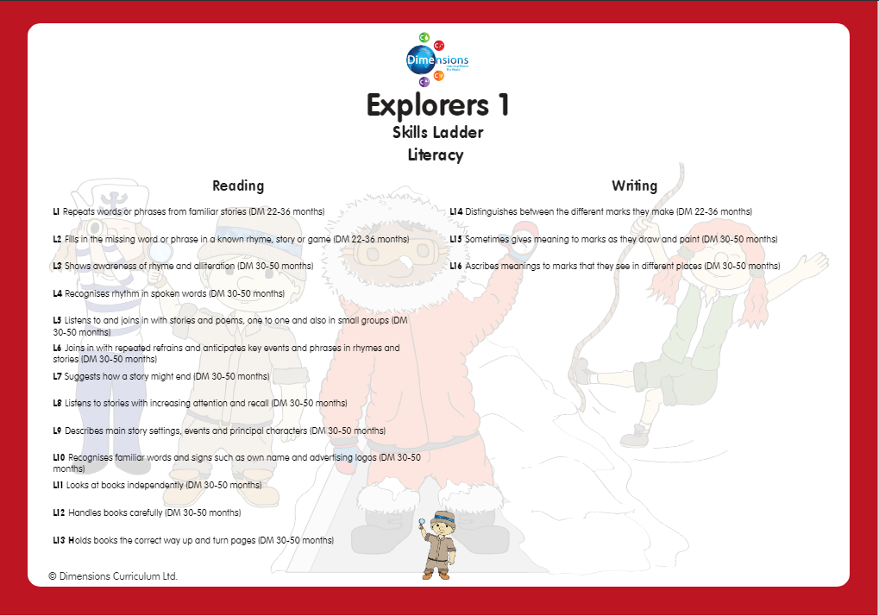

Appendix 2c: Dimensions writing opportunities
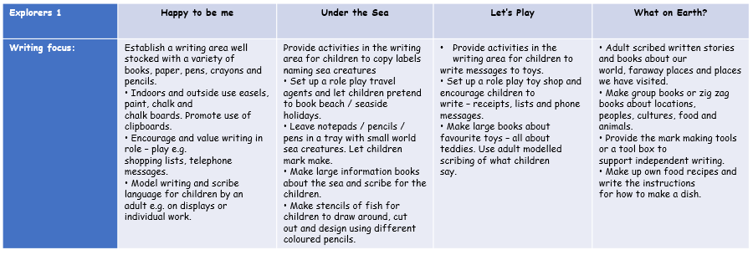
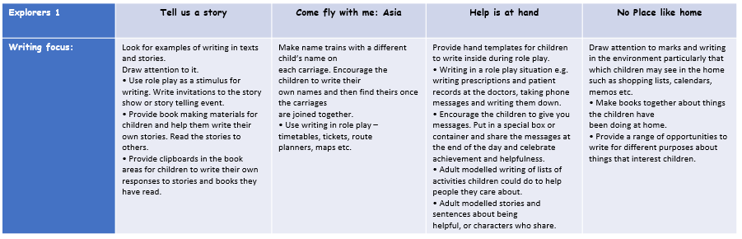

Appendix 3a: Literacy Counts Curriculum Coverage – Writing
Foundation: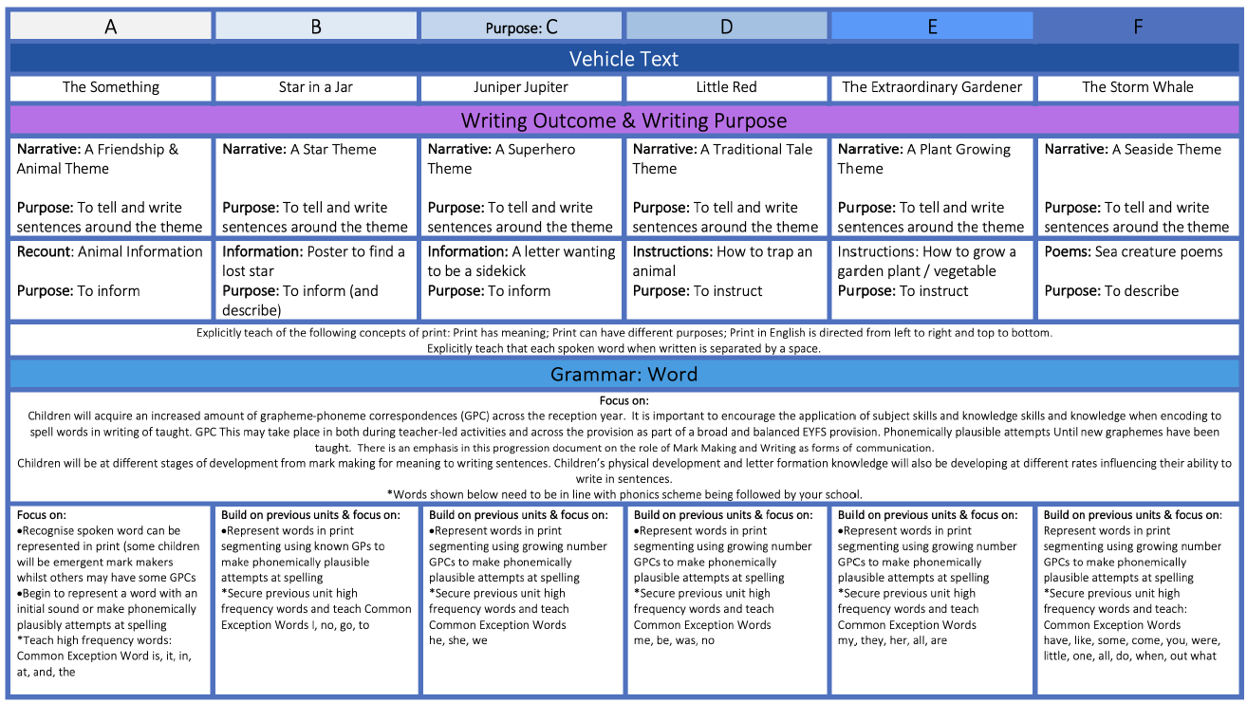
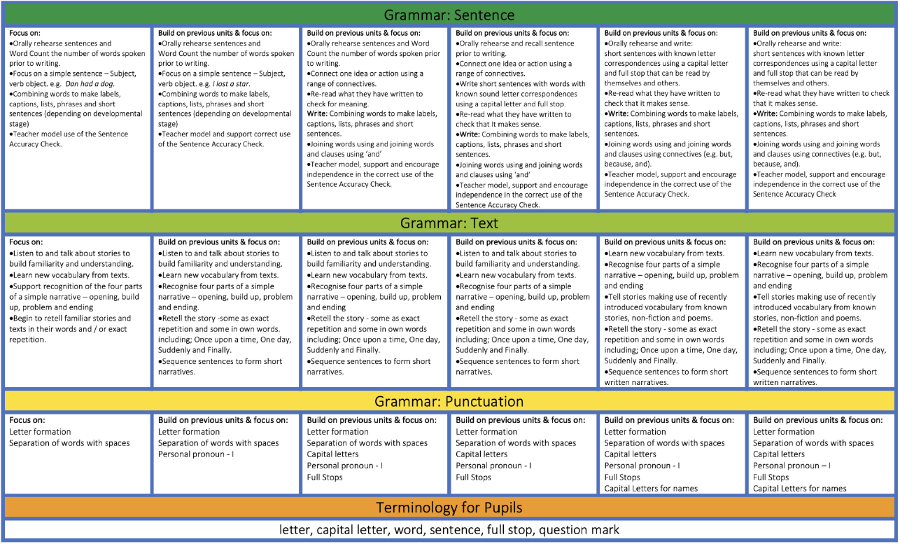

Year 1:
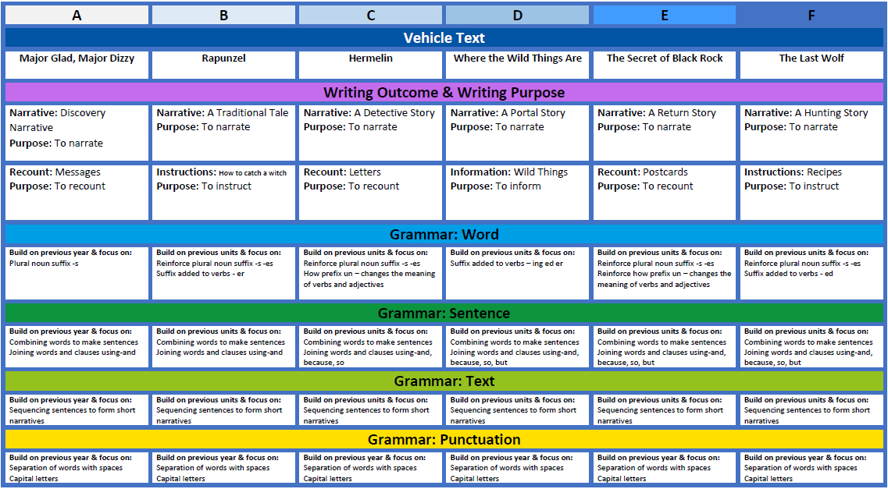
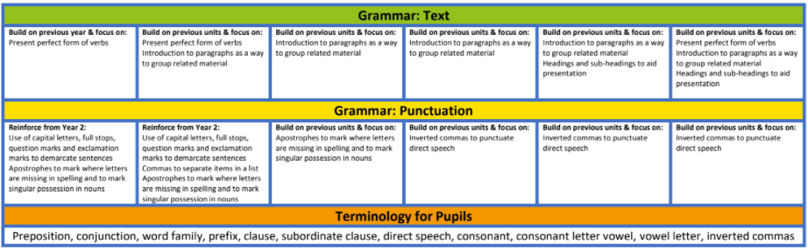
Year 2:
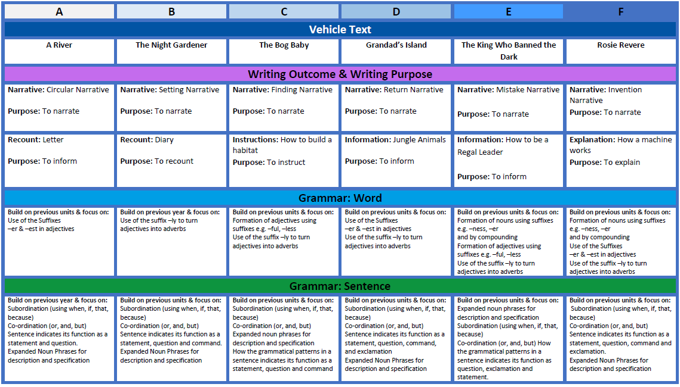
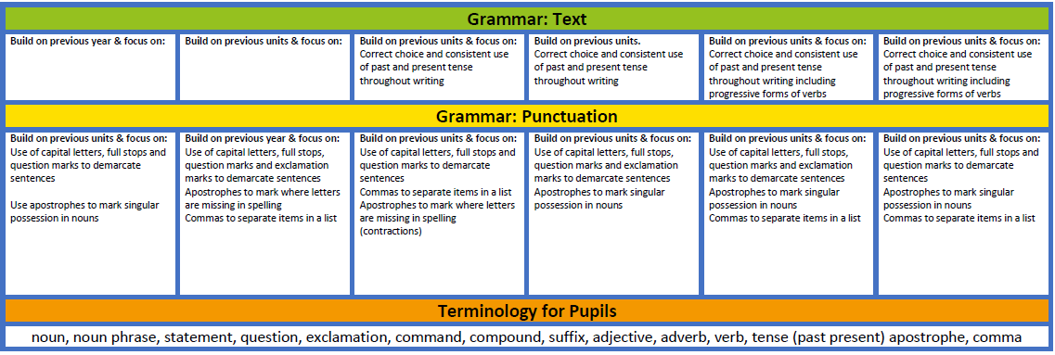

Year 3:
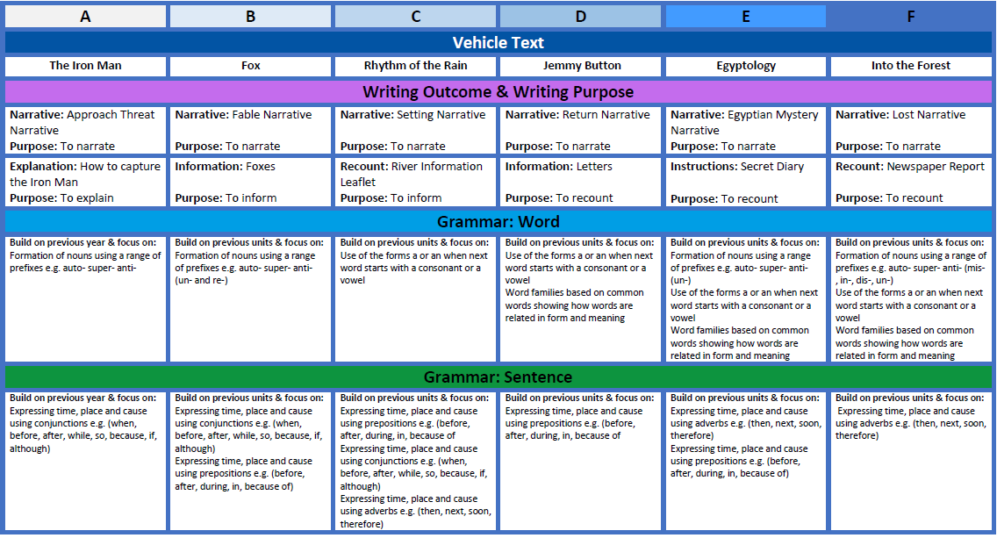
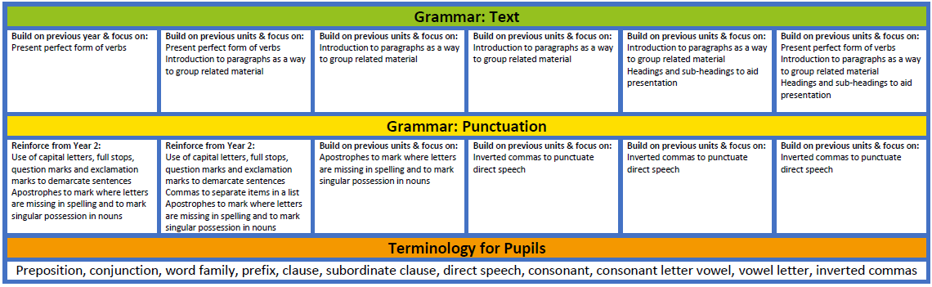

Appendix 4: Hayfield Summative Stages - Writing
